***CHEMISTRY 362***

# *Descriptive Inorganic Chemistry*

M. Y. Darensbourg

Examination II

March 22, 2019

Name: ________________________________________

**An Aggie does not lie, cheat or steal or tolerate those who do.**

**Useful formula:** μs.o. =

***See last page for Slater’s Rules and Point Group Flow Chart***

**I. Molecular Orbital Bonding Approach for Diatomics**Give (assign electrons) the molecular orbital electronic configuration of B2 , C2 and carbide, C22**−.**

1. Give the ground state term symbol, the bond order and the spin-only magnetic moment for each. Use the following horizontal form of the MO energy level diagram:

[KK] 2s *2s π 2p(x,y) σ2pz π*2p(x,y) σ*2pz

B.O. Term Symbol µS.O.

B2 ________________________________ ____ _____ ____

C2 ________________________________ ____ _____ ____

C22**−** ________________________________ ____ _____ ____

1. Match the bond distances of the three species: 1.20 Å____; 1.59 Å_____; 1.24 Å ______
2. On the following coordinate axes, sketch the HOMO of C2 and the LUMO of B2. Include signs on the orbitals.

 

1. Suppose the MO energy level diagram was ordered as it is when the s and p orbitals are well separated, i.e., [KK] 2s *2s σ2pz π 2p(x,y) π*2p(x,y) σ*2pz. If this was actually the order in the C2 molecule, what would the following be? B.O. ______; Term symbol ______; µS.O. ______
2. Carbide, C22**−**, is isoelectronic with cyanide, CN**−** . To what symmetry point groups do

C22**−**  and CN**−** belong? C22**−**  _______ CN**−** _______

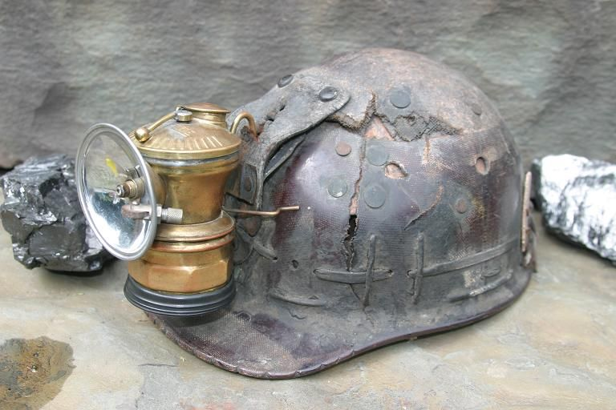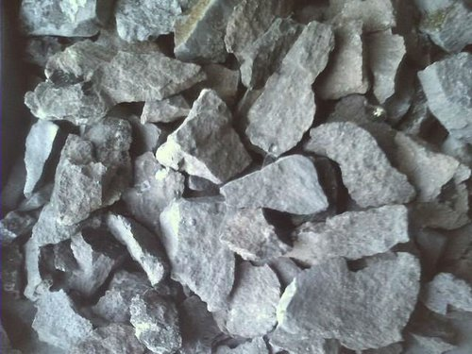

1. **Solids**

Calcium carbide, Ca2+ C22**−** was formerly widely used in miner’s lamps as when it reacts with water acetylene, C2H2 , is released; when ignited it burns with a brilliant light. Calcium carbide crystallizes in the rock salt (NaCl) structure.

1. Using the following figure, calculate the number of calcium ions and the number of C22- ions in the unit cell of calcium carbide. Show how you arrived at your answer.

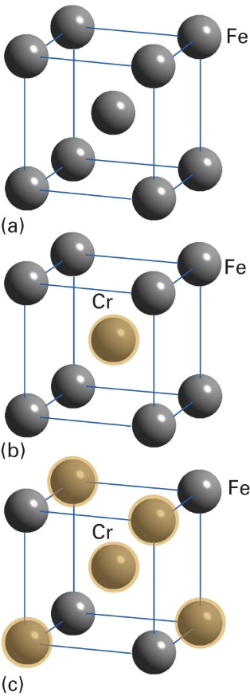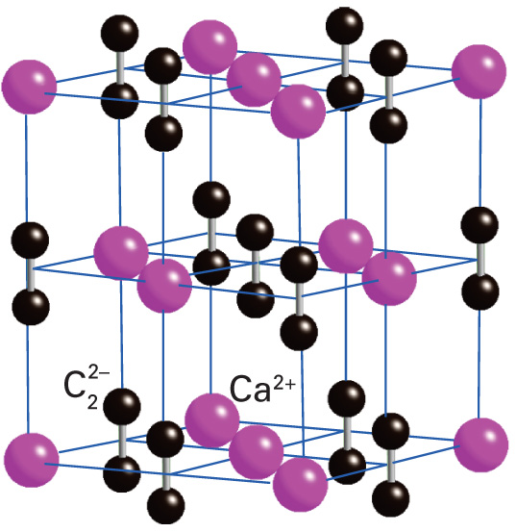

1. Answer the questions about the unit cell structures at right. Show how you derived your answers.
2. What is the name of the type of unit cell (a) and many Fe atoms are in this particular form of pure iron? ______________________________________
3. What is the formula of the (b) Cr/Fe mixture? _________
4. What is the formula of Cr/Fe mixture (c)? _________ Show how you came to this conclusion.
5. Species (c) represents (circle the correct answer)

intrinsic semi-conductor substitutional alloy interstitial alloy

1. 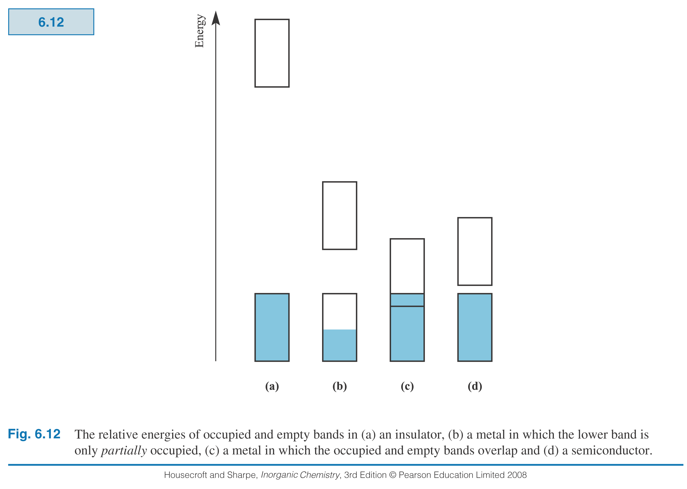The MO approach to bonding in metals leads to bands of molecular orbitals. Making use of the graphic shown at left, account for i) the fact that Lithium is   
   a metal and diamond is an insulator; ii) the temperature dependence of semi-conductors.
2. **Delocalized M.O.’s and Intermolecular Forces**

A product of HF + excess F- is the HF2— anion which may be described as containing the strongest known hydrogen bond. It is a linear molecular ion with equal distances between F and H on both sides. The anion HF2—  is an example where the MO theory (SALC) approach best explains delocalized, H-bridge bonding. The MO energy level diagram is given below and the most stable (bonding) MO of HF2—  is defined as ΨMO = H1s + (F2pz + F2pz).

1. Two other molecular orbitals, ΨMO*  and ΨMOnb are needed to complete the MO energy level diagram for each bridge bond. Formulate these MO’s and assign electrons. What is the bond order of the HF2— unit? (Hint: First give the Lewis structure.)

_______ ΨMO* =

_______ ΨMOnb =

_______ ΨMOb = H1s + (F2pz + F2pz).

1. The B2H6 likewise has a 3-center bond. The most stable MO of the diborane B-H-B bridge bond is ΨMO = H1s + (Bsp3 + Bsp3). Formulate the other two frontier MO’s: ΨMOnb and ΨMO*

________ ΨMO* =

________ ΨMOnb =

_______ ΨMOb = H1s + (Bsp3 + Bsp3).

Assign electrons to these molecular orbitals.

1. Which of the above contains a 3-center 2-electron bond and which is a 3-center 4 electron bond?
2. **Hydrogen fluoride**, chemical compound, **HF**, is a colorless, fuming liquid or colorless **gas** that boils at 19.54°C. It is miscible with **water** and is **soluble** in benzene, toluene, and concentrated sulfuric acid. What intermolecular interaction best accounts for the solubility of HF in **benzene**? Select your answer from the following list and briefly explain your choice.

a) dipole-dipole b) ion-dipole c) dipole-induced dipole d) London dispersion forces

1. **Thermodynamics and Solids**  
   Consider the Born-Haber cycle below.
2. Label each arrow with the appropriate thermodynamic process given below.
3. Using the data provided for M = lithium and X2 = fluorine, calculate the heat of formation for LiF (s).

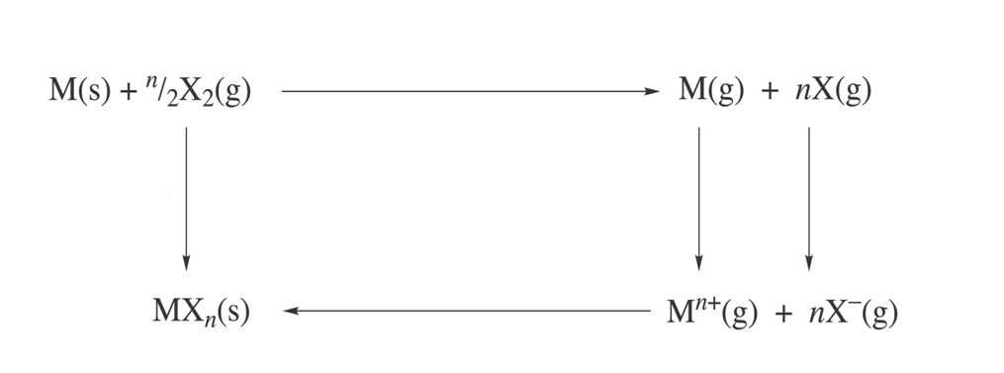

1. Lattice enthalpy change or Lattice Energy = - 1023 kJ/mol
2. Electron affinity enthalpy = - 328 kJ/mol
3. Ionization energy = + 520 kJ/mol
4. Bond dissociation Energy (1/2 F2 → F (g)) = + 79 kJ/mol
5. Atomization or Sublimation Energy = + 147 kJ/mol
6. Standard Enthalpy of Formation = ???? kJ/mol
7. Both CsF and LiF crystallize in the Rock Salt (NaCl) structure. The Standard Enthalpy of formation of CsF is -554kJ/mol and that of LiF is -617 kJ/mole. What term in the Born-Haber cycle most likely makes this difference? What term in the equation developed from theory for Lattice Energy is responsible for the difference? (Note: the Born constant, in the 1/n term or compressibility may be considered to be the same for both salts.)
8. The structures of diborane, B2H6, C2H6 (in its staggered form) and the amine-borane Lewis   
   complex are shown.

|  |  |  |  |
| --- | --- | --- | --- |
|  |  |  |  |
| 1. Give Principal rotation axis |  |  |  |
| 1. Yes or No? Contains inversion center, i |  |  |  |
| 1. Yes or No? Contains   nC2 ⊥ Cn |  |  |  |
| 1. Yes or No? Contains S6 |  |  |  |
| 1. Give Point Group |  |  |  |

***For Grading Use:***

|  |  |  |
| --- | --- | --- |
| **Question** | Points possible | **Points received** |
| I | 25 |  |
| II | 15 |  |
| III | 16 |  |
| IV | 20 |  |
| V | 24 |  |
| Total | 100 |  |

Name: ________________________________________

